Gaming Reviews

By. Alexander Sanchez

My review on… The crew motorfest

A racing game by Ubisoft for $60

You can buy it on PlayStation and PC.

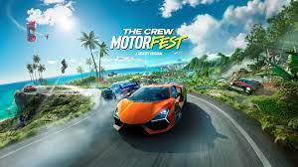

My review on… Fortnite By EPIC GAMES

Free

You can play it on

PlayStation

XBOX

Nintendo

PC

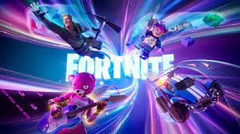

**Amazing animals, The Beluga Whale**

**By. Bruce Kilburn**

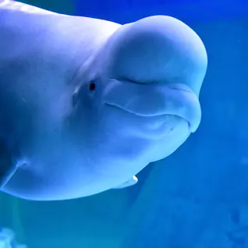

Beluga whales are awesome animals that are both aquatic and breathe air! These whales are huge, they can grow up to 32ft long and 3600lmb! Belugas are gentle giants they have no record of ever attacking a human. They make a wide variety of sounds such as mews, chirps, and clicking sounds. Beluga whales live between 35-50 years old. The whales eat fish, squid, and octopi. And the thing on their head is called a melon it helps them use echolocation to find food.

Stella

By Lily Waite

I have a pet named Stella. Stella is one of the craziest dogs I've ever seen in my entire life. Stella loves to cuddle with me, my mom and my sister. My dog Stella thinks she owns the house. She loves to go outside, bark, and annoy the neighbors. When one of my parents tries to hug me, Stella tries to get them to stop like she's protecting me. Stella is a Corgi and a Chihuahua mixed. It's funny seeing her try to protect me like a guard dog and try to be scary but really, she's not scary at all. Stella loves to look through the window and bark at people walking and driving by. Stella will do ANYTHING for food. She acts like we don't feed her but really, she just wants a treat. Stella is afraid of fireworks, when she hears fireworks, she will run to me or my mom and shake like crazy. She will jump into your arms and tries to climb onto you. I love Stella so much and nothing will ever make me stop loving her.

My favorite Memory  
By: Annie Nguyen

One of my favorite memory was when I had a field trip. I was going to a Folk Fair for a field trip. At the Folk Fair they had really good food. My favorite food from the Folk Fair was the BBQ chicken. The Folk Fair was very fun. But sadly, it ended.

EV book review

By. Au’dria Thompson

Enterprise Village article is fun the best part is when your get to apple for a job just make sure you turn it in cause if you done u may not get the job you wanted what all jobs are fun but make sure u get all your work down u have to do 2 book things but it will go by fast so its alright but when your done with that just know you go home when you come back your going on your way it will be so so much fun!